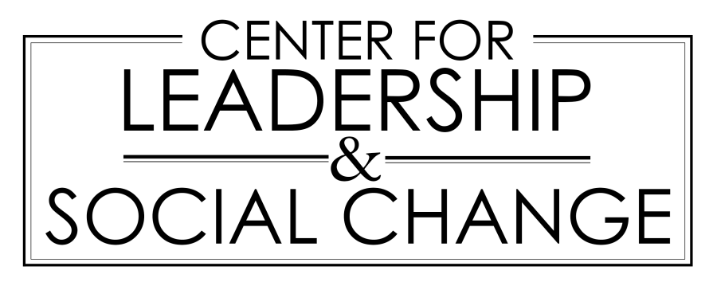

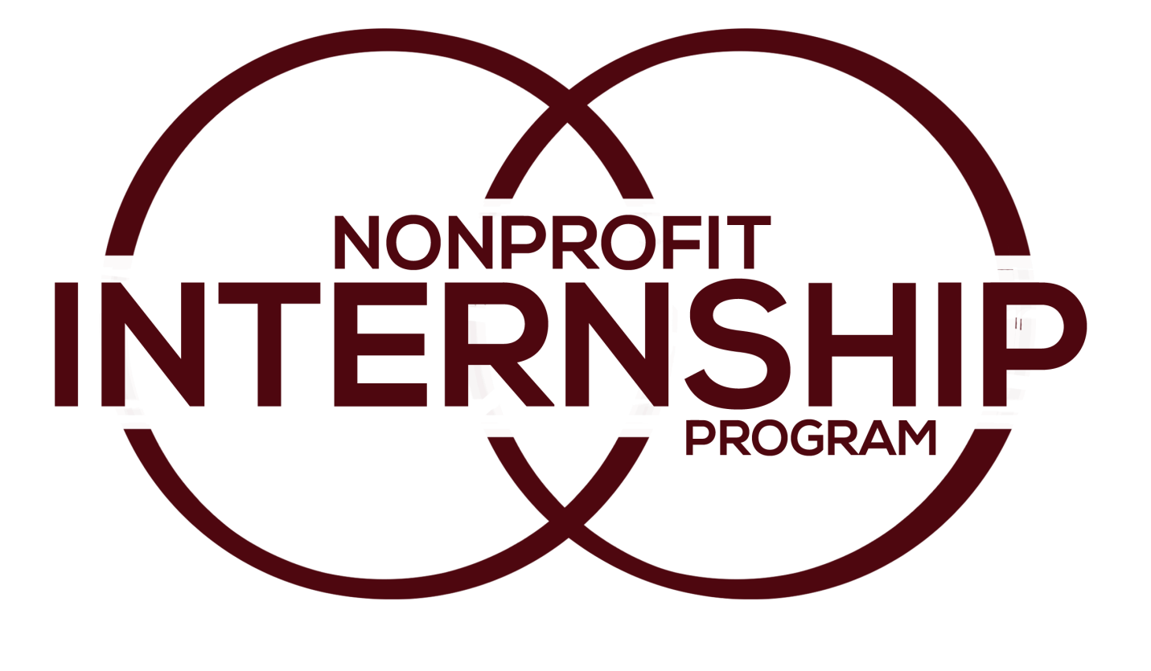

Florida State University

Name of Organization………………………………………….…………………………….
America’s Second Harvest……….………………………………………………………………………….
Bicycle House……………………………………………………………………………………………………..
Big Bend Homeless Coalition………………………………………………………………………………
Big Brother/Big Sister of the Big Bend…………………………………………………………………
Bread and Roses Food Cooperative…………………………………………………………………….
Capital Area Chapter of the American Red Cross………………………………………………..
Capital City Youth Services…………………………………….……………………………………………
Children’s Home Society Model Program…………………………………………………………...
Cornerstone Learning Community…………………………………….………………………………..
Department of Corrections…….…………………………………………………………………………..
DISC Village: St Marks Lodge…………………………………………………….…………………………
The Early Learning Coalition of the Big Bend……………………………………………………….
FAVACA……………………………………………………………………………………………………………….
Florida Association of School Administration…………………………………………………..….
Florida Department of Financial Services…………………………………………………………….
Florida Department of Public Health…………………………………………………………………..
Florida Division of Emergency Management…………………………………………………..….
Florida League of Women Voters………………………………………………………………………..
Florida Library Association………………………………………………………………………………….
FSU Center for the Advancement of Human Rights……………………………………….…...
Genesis Church……………………………………………………………………………………………………
Grace Mission Church………………………………………………………………………………………….
Hartsfield Elementary School………………………………………………………………………………
Kids Incorporated of the Big Bend……………………………………………….……………………..
The Legal Aid Foundation of the Tallahassee Bar Association……………………………..
Legal Services of North Florida: Refuge House……………………………………………………
Leon County Health Department/Area 2B HIV/ AIDS………………….………………………
Lincoln High School…………………………………………………………………………………………….
National Alliance on Mental Illness…………………………………………………………………….
The Oasis Center for Women & Girls………………………………………………………………….
Open Door Women’s Clinic…………………………………………………………………………………
PACE Center for Girls………………………………………………………………………………………….
Palmer Munroe Teen Center………………………………………………………………………………
Pediatria…..…………………………………………………………………………..……………………………
Pregnancy Help and Information (PHI) Center…………………………………..……………….
Public Defenders Office.……………………………………………………………………………………..
Southern Scholarship Foundation……………………………………………………………………….
Tallahassee Memorial Hospital…………………………………………………………………………..
United Way…………………………………………………………………………..……………………………
Westminster Oaks………………….…………………………………………………………………………..
Who We Play For………………………………………………………………………………………………..
W.T. Moore Elementary School………………………………………………………………………….
Young Life Tallahassee………………………………………………………………………………….…...
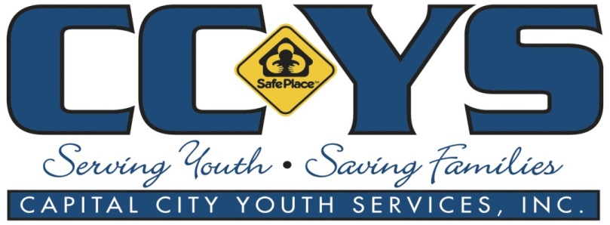
Capital City Youth Services
Address: 2407 Roberts Ave, Tallahassee, FL 32310
Telephone number: (850) 576-6000
Website: www.ccys.org
The Mission of Capital City Youth Service:
Capital City Youth Services offers counseling and outreach services to youth and their families, and emergency shelter services to youth in crisis. Among the services CCYS provides are CINS/FINS services, which are funded by the Department of Juvenile Justice through the Florida Network of Youth and Family Services. CINS stands for "Child In Need of Services" and FINS stands for "Family In Need of Services". These are interventions designed to address behaviors that put youth at risk for delinquency.They serve youth and families throughout the Big Bend area of North Florida.

Testimonials:
-“Throughout this internship I was primarily responsible for supervising the youth. Other tasks included preparing morning activities, leading social skills, maintaining accurate records, and assisting the youth.” – Otgna D.
-“My Chief responsibilities included: planning and facilitating group activity/therapy once a week, intakes, screening calls creating new files, youth supervision, and other various task.” – Landis B.
-“My responsibilities during my internship changed often. It ranged from basic supervision of the youth, to leading social skills groups, all the way down to making intake files. Occasionally I would manage donations and Goodwill runs as well.” – Leslie G.
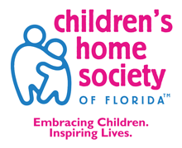
Children’s Home Society Model Program
Address: 1801 Miccosukee Commons Drive, Tallahassee, FL 32308
Telephone number: (850) 921-0772
Website: www.chsfl.org
The Mission of Children’s Home Society Model Program:
Healthier, stronger families are key to keeping more children safe and secure. Through parent education, counseling, early education and care, in-home services, and connections to local resources, the Children’s Home Society help families learn to nurture their children to full potential. They also help families raising children with developmental delays. Offering physical and speech therapy, nursing and medical services, counseling, and more, they help kids reach milestones while providing hope to the entire family. They do this through individual and family counseling, parents and children learn how to cope with stress, anger, discipline, depression, and other feelings and situations.

Testimonials:
-“In the CHS MODEL mentoring program where I am doing my internship, they’re always looking for new ways to inspire the mentor/mentee pairs to spend more time doing new, exciting, and educational things together. This lead to the creation of a new rewards system called MAP (MODEL Adventure Points).” – Susan C.

DISC Village: St Marks Lodge
Address: 3333 West Pensacola Street #300; Tallahassee, Florida 32304
Telephone Number: (850) 575-4388
Website: www.discvillage.com
The Mission of DISC Village:
Their centers facilitate appropriate coordination of client-treatment matching, along with juvenile outpatient, adult outpatient, urinalysis, prevention/intervention, and Treatment Alternatives for Safe Communities (TASC) services. DISC Village has developed a series of partnerships in Leon County. The agency collaborated with Florida's Department of Children and Families and Department of Juvenile Justice, Juvenile Alternative Service Program (JASP), City of Tallahassee, Leon County, and other private providers to implement one of the state's most comprehensive Juvenile Assessment Centers.

Testimonials:
-“I learned how to become a better leader/role model. I have gained social skills and other skills that will prepare me for my future profession.” – Shericka C.
-“I hoped that starting a library at the home will encourage them to do the same, whether they choose to attend college or not.” –Michelle S.

Kids Incorporated of the Big Bend
Address: 2326 Centerville Rd, Tallahassee, FL 32308
Telephone: (850) 414-9800
Website: www.kidsincorporated.org
The Mission of Kids Incorporated of the Big Bend:
The Kids Incorporated of the Big Bend helps families living on or below the poverty line in 6 areas: School readiness, Curriculum, Individualization, Health Disability & Nutrition services, Child Assessment, Family Services.
Testimonials:
-“My responsibilities included assisting staff in the office and the classroom. I was expected to create and maintain trust with the kids and aide them in their learning.”–Chelsey P.

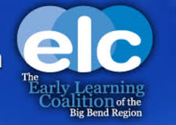
The Early Learning Coalition of the Big Bend
Address: 1940 N Monroe St #70, Tallahassee, FL 32303
Telephone: (850) 385-0504
Website: www.elcbigbend.org
The Mission of Early Learning Coalition of the Big Bend:
The main goal of ELC is to ensure that all children are prepared for success in school. They do this by providing a leadership and advocacy that builds a community where all children are prepared for success in school.

Testimonials:
-“I assisted Braint in working with the volunteers and planning community events. At the end I became in charge of the volunteers, giving orientations and placed volunteers in centers.” –Andrea E.

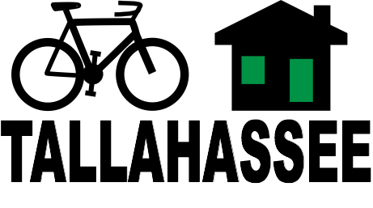
Bicycle House
Address: 1317 Jackson Bluff Rd, Tallahassee, FL 32304
Telephone: (850) 350-8000
Website: www.bicyclehouse.org
The Mission of Bicycle House:
The goal of Bicycle House is to guide folks along a safe pathway toward self-reliance - “help people learn to help themselves.” Their mission is to provide safe bicycles to people who need transportation. The Bicycle House has 4 main projects: Elberta Park HUB, Street Sweepers, FAMU Bicycle Initiative, and Shop Expansion. To become a volunteer is simple, after completing a 2-hour orientation you will be assigned a once-a-week 4 hour shift.

Testimonials:
-“My responsibilities include creating the volunteer & Build-A-Bike schedule for the shop as well as amateur mechanic. I helped in organizing the shop, coordinating volunteers and events, promoting the shop and helping with future development.” – Joshua V.

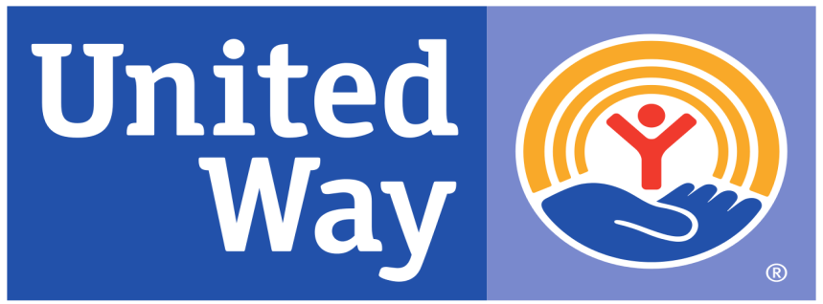
United Way
Address: 307 E 7th Ave, Tallahassee, FL 32303
Telephone: (850) 414-0844
Website: www.uwbb.org
The Mission of United Way:
The mission is to unite the support of our citizens to make a stronger, safer, and healthier community. The United Way of the Big Bend focus on the things that everyone needs for a good life: a quality education that leads to a stable job, enough income to support a family through retirement, and proper health care. They bring together the people and organizations from across the community who share in their vision and have the energy, expertise, and resources to get the work done. Those people are essential to their success and the success of our community. That’s what it means to LIVE UNITED – working together, solving problems, and bringing about lasting change.

Testimonials:
-“, I'm currently taking a public administration class and everything I have learned in that class is applicable to United Way's administrative work. One of the biggest concepts in the class has to deal with employee/employer relationships.” - ######

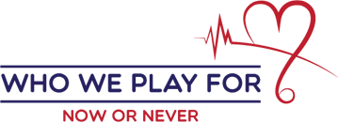
Who We Play For
Telephone: (850) 350-8000
Website: www.whoweplayfor.org
The Mission of Who We Play For:
Who We Play For has a movement is to inspire you with our story of playing for Rafe so that you, too, can make a difference for someone you love. They believe everyone has someone or something they play for. They believe there is a motivation, a why, behind what they all do. Their hope is that with their story of overcoming adversity and making an impact for something bigger than ourselves, we can inspire others to do the same. They have screened hearts, donated automated external defibrillators, and educated parents, teachers, and coaches on how to identify and prevent sudden cardiac arrest. Their aim is to save as many lives as possible.

Testimonials:
-“During my internship the tasks I was responsible for dealt with organizational growth, such as scholarship, partnership and fundraising.” – Kyle E.
-“The project I took on was passing the Sudden Cardiac Arrest Prevention Act in Florida. This projects purpose was to promote conversations with state legislatures about the importance of protecting against the #1 killer of student athletes, Sudden Cardiac Arrest.” – Evan E.

Young Life
Address: 820 E. Park Ave Unit B Tallahassee, FL 32301
Telephone: (850) 727-0032
Website: www.tallahassee.younglife.org
The Mission of Young Life:
In Young Life they give kids the first word. They go into their lives with open ears and listen. Young Life knows that kids don’t care what we know till they know how much we care. In Young Life, they call that earning the right to be heard. They invite kids into respectful relationships and into more fun and adventure (at club and camp, for example) than they can imagine. Young Life doesn’t start with a program. It starts with adults concerned enough about kids to go to them, on their turf and in their culture, building bridges of authentic friendship. These relationships don’t happen overnight — they take time, patience, trust and consistency.

Testimonials:
-“I’m learning a lot about delegation & management of other people. Getting to see all aspects of the way a nonprofit works” – Kelsey D.

W.T. Moore Elementary School
Address: 1706 Dempsey Mayo Rd, Tallahassee, FL 32308
Telephone: (850) 488-2858
Website: www.moore.leon.k12.fl.us
The Mission of W.T. Moore Elementary School:
The mission of W. T. Moore is to prepare students to become responsible, respectful, independent learners equipped with the critical thinking skills necessary to compete in our global society. W.T. Moore aims to be an engaging, safe and respectful learning environment that embraces change and produces successful learners who value diversity and are conscientious contributors to our society.

Testimonials:
-“During the course of my internship I was responsible for a variety of duties including: counseling students, preparing and implementing lessons, completing paperwork, assisting parents, leading student groups, answering phones, administering I.Q. tests, attending meetings, and monitoring student progress.” –Rebecca L.

PACE Center for Girls
Address: 1344 Cross Creek Cir, Tallahassee, FL 32301
Telephone: (850) 921-9280
Website: www.pacecenter.org
The Mission of PACE Center of Girls:
PACE Center for Girls, Inc. is a nationally recognized and research based model that features a balanced emphasis on academics and social services with a focus on the future for middle and high-school aged girls and young women. The foundation of PACE is the gender-responsive culture, providing a safe environment that celebrates girls, services that take into account how girls learn and develop, and staff that understand the lives of girls and can respond to their strengths and challenges.

Testimonials:
-“I worked with Kelly Otte on the Leon Country Commission on the Status of Women and Girls for my project this summer. It was a great opportunity to see the policy side of social work and to work with some amazing women in the Tallahassee community.” – Erin B.

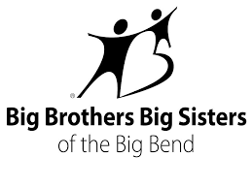
Big Brother/Big Sister of the Big Bend
Address: 565 E Tennessee St, Tallahassee, FL 32308
Telephone: (850) 386-6002
Website: www.bigbendmentoring.org
The Mission of Big Brother/ Big Sister of the Big Bend:
Each time Big Brothers Big Sisters pairs a child with a role model, they start something incredible: a one-to-one relationship built on trust and friendship that can blossom into a future of unlimited potential. And thanks to the first-ever nationwide impact study of a mentoring organization, they have the facts to prove it.
Testimonials:
-“Working at BBBS and having completed my project was the “icing on the cake” to complete my working experience. I have experienced a lot, I have done a lot, and I have learned a lot. I am leaving this internship a whole different person than when I started” – Sade H.
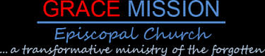
Grace Mission Church
Address: 303 W Brevard St, Tallahassee, FL 32301
Telephone: (850) 224-3817
Website: www.gracemission.net
The Mission of Grace Mission Church:
Grace Mission in Tallahassee, FL has been a downtown Christian community for 16 years. It was founded in the mid- 1990's (see our history section) with a vision of planting a radical kind of ministry that was and still is focused on worship, while crossing racial, social, and economic lines to minister to the whole person. They are a ministry to the 'least of these' - a ministry about people - loving them in the name of Jesus. Grace Mission also supports other ministries and partners with other agencies within the Frenchtown community. They realize the importance of cooperation and communication with others to help achieve common goals.

Testimonials:
-“A main responsibility that interns must handle is interacting with the homeless and poor population in the Frenchtown area.” – Nahomie P.
-“My responsibilities included planning heritage festival, riding bus on Tuesday when volunteers didn’t show up, unload Friday food truck, and other various tasks.” – Stephanie G.iu

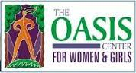
The Oasis Center for Women & Girls
Address: 317 E Call St, Tallahassee, FL 32301
Telephone: (850) 222-2747
Website: www.theoasiscenter.net
The Mission Oasis Center for Women & Girls:
They are a nonprofit organization in Tallahassee whose mission is to "improve the lives of women and girls through celebration and support". They are focused on personal, professional, and economic concerns facing women, girls and their families. They are committed to addressing these issues individually through the provision of direct services and collectively through community dialogue and awareness.

Testimonials:
-“At my internship I have been working with the Commission’s drafts and making edits, with the track changes on.” - Emily B.

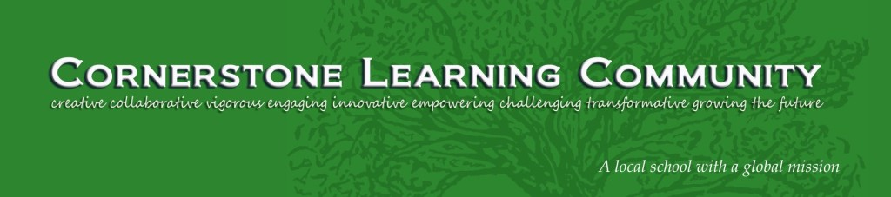
Cornerstone Learning Community
Address: 2524 Hartsfield Rd, Tallahassee, FL 32303
Telephone: (850) 386-5550
Website: www.cornerstonelc.com
The Mission of the Cornerstone Learning Community:
The CLC is a private school with a public mission. This means they treat parents as partners, teachers as leaders, and students as individuals. They aim to be a model for what schools can be, both in terms of engagement with the broader community and in cultivating professionalism in the education field. In everything we do at CLC, they incorporate our seven Core Virtues, adopted from Ernest Boyer’s The Basic School. They are: Respect, giving, compassion, perseverance, self-discipline, responsibility, honesty.

Testimonials:
-“I was responsible for the supervision of children (ages 3-7) early morning prior to school. I provided instruction, safe-keeping, and support throughout the day.” – Sophia L.
-“My responsibilities included participating in group therapy, male calls to the case managers, guardian ad litem, attorneys, doctors, etc. I would also be in charge of helping the boys get things they needed, help make decisions on in-takes.” –Michelle S.

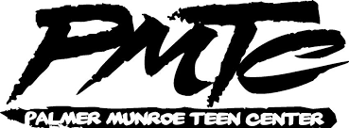
Palmer Munroe Teen Center
Address: 1900 Jackson Bluff Rd, Tallahassee, FL 32304
Telephone: (850) 891-2569
Website: www.facebook.com/pmtcteens
The Mission of the Palmer Munroe Teen Center:
For years, the Tallahassee community has been asked to provide a place dedicated to teen youth development; a place dedicated to serving some of our most vulnerable youth; a place for teens to expand their opportunities, learn about social responsibility, civic awareness and be gently guided through a restorative justice program. In August 2010, the Palmer Munroe Teen Center opened its doors as the first teen center in Tallahassee, Florida. Collaboration between the City of Tallahassee, Leon County, Leon County Schools, and the Department of Juvenile Justice, the Palmer Munroe Teen Center offers a unique blend of educational classes, workshops, programs and recreation activities for youth. The Center also serves as a safe, productive oriented haven for many area youth.

Testimonials:
-“The supervision is relax – you receive a task list for each week and then it is up to you to complete them. Supervision is more like support.” – Janel R.

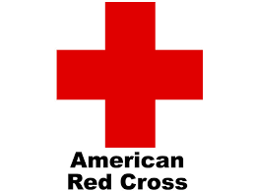
Capital Area Chapter of the American Red Cross
Address: 1115 Easterwood Dr, Tallahassee, FL 32311
Telephone: (850) 878-6080
Website: www.redcross.org/fl/tallahassee
The Mission of the Capital Area Chapter of the American Red Cross:
The American Red Cross exists to provide compassionate care to those in need. Our network of generous donors, volunteers and employees share a mission of preventing and relieving suffering, here at home and around the world, through five key service areas: Disaster relief, supporting America’s Military Families, lifesaving blood drive, health and safety services, and international services.

Testimonials:
-“My main responsibilities during my internship were being in charge of the outreach activities, as well as the FAST director.” –Michael H.
-“Some of my responsibilities included delivering lectures and activities with school-aged children on the topics of personal hygiene and first aid.” – Monica A.
-“ American Red Cross offers an array of services, including Disaster Services, Health & Safety Services, Military Services, Preparedness, and International Services. The Capital Area Chapter had a very underdeveloped International Service are, in an attempt to expand their international services, I came on board as the international service intern.” – Claudia A.
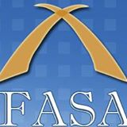
Florida Association of School Administration
Address: 206 S Monroe St, Tallahassee, FL 32301
Telephone number: (850) 224-3626
Website: www.fasa.net
The Mission of FASA:
FASA has divided the state into four regions to allow for representation of each region on all Department Boards. The regions are divided as shown in the map below. Each Region has a Region Director, two Elementary and Middle School Principals (FAEMSP), two Secondary School Principals (FASSP), two Assistant Principals (FAPA), two Instructional Supervisors and Administrators (FAISA), two Support Administrators (FSAA) and one Professor of Educational Leadership (FAPEL). The purpose of the Florida Association of School Administrators (FASA) is to help its members meet their responsibility through a professional organization dedicated to the development of effective educational leadership.
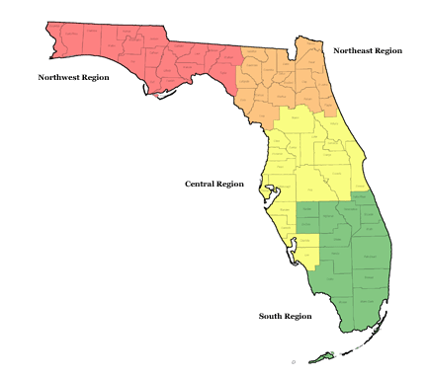
Testimonials:
“I chose this agency because I wanted experience in Event-Planning, and knew I could do just that here. Although it is not my major it was always a field I always enjoyed in everyday life.” – Lindsay D.
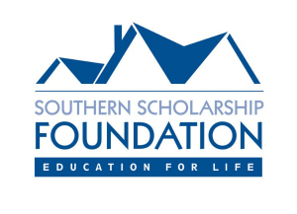
Southern Scholarship Foundation
Address: 322 Stadium Dr Tallahassee, FL
Telephone number: (850) 222-3833
Website: www.southernscholarship.org
The Mission of Southern Scholarship Foundation:
The Mission of SSF is to help deserving young people who lack financial resources, but demonstrate excellent academic merit and good character, attend institutions of higher education. Qualified students attending Florida A&M University, Florida Gulf Coast University, Florida State University, Santa Fe College, Tallahassee Community College, and University of Florida are awarded scholarships in the form of rent-free housing to live in one of twenty-six, furnished scholarship houses that are adjacent to their college campus.
Testimonials:
-“This internship is going to teach you many different things that can be applied to all aspects of life. You will get to experience many different things while working this internship. You will interact with different types of people as well as take care of a variety of daily tasks.” -Julian

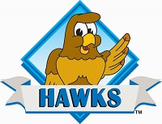
Frank Hartsfield Elementary School
Address: 1414 Chowkeebin Nene, Tallahassee, FL 32301
Telephone: (850) 488-7322
Website: www.leonschools.net
The Mission of Frank Hartsfield Elementary School:
The education, character development, health and safety of our students are part of their commitment to the students and families of Hartsfield Elementary School. At Hartsfield, we make it a goal to work cooperatively with our staff, parents, and community members to set high expectations. In trying to meet these expectations, FHES have teams of teachers dedicated to monitoring the school programs that are in place to support the classroom instruction. Their teachers have a commitment to plan and deliver instructional strategies that are supported by research, are proven effective through progress monitoring, and are enhanced through academic intervention, guidance assistance, afterschool enrichment, and student recognition ceremonies.

Testimonials:
-“After speaking with Ms. Howard (supervisor) we came up with the idea that I can create two bingo games for the class that will help drill the concepts of basic colors and shapes into their heads.” – Cason B.
-“My number one goal is to help my group of 4 kids learn to identify as many letters of the alphabet as possible.” – Chandra P.
Lincoln High School
Address: 3838 Trojan Trail, Tallahassee, FL 32311
Telephone: (850) 487-2110
Website: www.lincoln.leon.k12.fl.us
The Mission of Lincoln High School:
The mission of the Lincoln High School community is to educate all students in a safe, nurturing and respectful environment that empowers them to become lifelong learners and productive citizens in a global society.

Testimonials:
-“My responsibilities at Lincoln High School includes: help manning the front desk when counselors are doing “busy work”, sitting in meetings and mediations, helping students sign up for SAT, ACT, answering student’s questions about bright futures and other academic issues. I also sit in during presentations, help organize and distribute standardized test, and other things along that line.” – Caitlin B.
FAVACA
Address: 1310 Paul Russell Rd, Tallahassee, FL 32301
Telephone: (850) 410-3100
Website: favaca.org
What Fava/Ca does:
The Florida Association for Volunteer Action in the Caribbean and the Americas, Inc. (FAVACA), is a private not for profit organization formed in 1982 by Florida Governor (now former U.S. Senator) Bob Graham. FAVACA's Florida International Volunteer Corps is the only program of its kind in the country and enjoys statutory authority under Section 288.0251 Florida Statutes. A state appropriation, voted annually since 1986, provides a funding base for an estimated 100 volunteer missions to Latin America and the Caribbean each year.

Testimonials:
-“My project focused on the organization of the intern orientation and the strengthening of the internship program binder.” - Silvia G.
-“3 components from my internship that I believe are effective measures of professional development are self-sufficiency, good communication skills, and background knowledge of FAVACA.” – Kylie F.
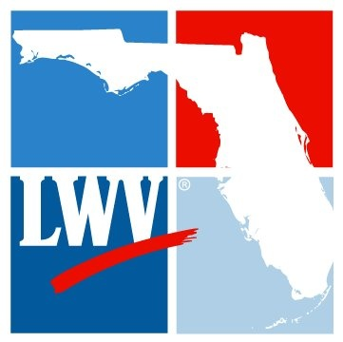
Florida League of Women Voters
Address: 540 Beverly Court, Tallahassee, FL 32301
Telephone: (850) 224-2545
Website: thefloridavoter.org
The Mission of Florida League of Women Voters:
The League of Women Voters of Florida, a nonpartisan political organization, encourages informed and active participation in government, works to increase understanding of major public policy issues, and influences public policy through education and advocacy. The League is a grassroots organization, working at the national, state and local levels. The League of Women Voters is strictly nonpartisan; they neither support nor oppose candidates for office at any level of government. At the same time, the League is wholeheartedly political and works to influence policy through advocacy. They are the original grassroots citizen network, directed by the consensus of our members nationwide. The 900 state and local Leagues comprise a vast grassroots lobby corps that can be mobilized when necessary.
Testimonials:
-“You will be working alongside strong and intelligent women who are achieving in their own ways. From the inaugural executive director under the age of 30 to the local advocacy leader, you will have the chance to see each staff member thrive in their own realm. Soak it up! There is a lot to learn and observe from each woman. “– Amber W.

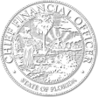
Florida Department of Financial Services
Address: 200 East Gaines Street, Tallahassee FL 32399
Telephone: (877) 693-5236
Website: www.myfloridacfo.com
The Mission of Florida’s Department of Financial Services:
The Department of Financial Services is headed by the Chief Financial Officer. The Division of Insurance Fraud (DIF) is the law enforcement arm under the Department and is responsible for investigating all various types of insurance fraud. The Division of Insurance Fraud has six regions located throughout the state of Florida, each commanded by a law enforcement captain; and 23 squads, each supervised by a lieutenant. Additionally, the Division consists of 150 sworn officers and 46 civilian support staff members.

Testimonials:
-“The major project assigned to me as a Gubernatorial Fellow was to produce Florida’s Bottom Line.” –Nicolas R.
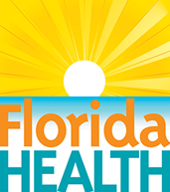
Florida Department of Public Health
Address: 2585 Merchants Row Boulevard Tallahassee , FL
Telephone: (850) 245-4444
Website: www.floridahealth.gov
The Mission of The Department is an executive branch agency, established in section 20.43, F.S. The Department is led by a State Surgeon General, who serves as the State Health Officer and is directly appointed by Florida’s Governor, and confirmed by Florida’s Senate. The Department has three deputy secretaries that oversee all of its business and programmatic operations. The Department is comprised of a state health office (central office) in Tallahassee, with statewide responsibilities; Florida’s 67 county health departments; 22 Children’s Medical Services area offices; 12 Medical Quality Assurance regional offices; nine Disability Determinations regional offices; and four public health laboratories. Facilities for the 67 county health departments (CHDs) are provided through partnerships with local county governments. These 67 CHDs have a total of 255 sites throughout the state, providing a variety of services, and ranging from small to large in location size.

Testimonials:
-“If you intern during the spring semester, you will likely be exposed to political side of the Department of Health, as January through April is usually devoted to work related to session. During the fall semester, I am told that things go a lot more slowly.” – David M.

National Alliance on Mental Illness
Address: NAMI-Tallahassee, Inc. P.O. Box 14842 Tallahassee, FL 32317
Phone Number: (850) 841-3386
Website: www.nami-tallahassee.org
The Mission of NAMI:
NAMI Tallahassee is the local affiliate of NAMI (National Alliance on Mental Illness) serving Leon and surrounding counties. Founded in 1979, NAMI has become the leading voice on mental illness. NAMI includes over 1,200 affiliates in every state who join together to meet the NAMI mission through support, advocacy, education, and research for people with mental illness, their families and friends. NAMI Tallahassee sponsors educational programs, a monthly support group; the 12-week Family-to-Family Education program; "Sharing Hope" for African American congregations; NAMI Basics, a 6-week education program for parents and caregivers of children and adolescents living with mental illnesses; Crisis Intervention Training for law enforcement (CIT) and Mental Illness Awareness Week.
Testimonials:
-“This internship will require patience, since mental health is personal and complex and mental health care is just as complicated and often insufficient, especially in Florida due to a variety of factors.” - Ellen

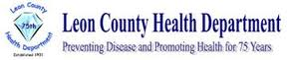
Leon County Health Department/Area 2B HIV/ AIDS
Address: 2965 Municipal Way, Tallahassee, FL 32304
Telephone: (850) 606-8150
Website: www.leoncountyfl.gov/lchd
The Mission of Leon County Health Department:
The LCHD continue our mission to "promote health, prevent disease," through their four locations: Roberts and Stevens, Richardson-Lewis also known as "Southside", Environmental Health, Molar Express [Dental].

Testimonials:
-“I had many responsibilities that changed over time, due to the great independence afforded to me. But some of them included cataloging the pamphlets and brochures, doing many types of outreach activities, helping out during and teaching HIV programs, creating a family relationship PowerPoint, and so much more.” – Chris R.

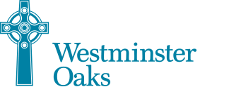

Westminster Oaks
Address: 4449 Meandering Way, Tallahassee, FL 32308
Telephone: (850) 878-1136
Website: www.westminsterretirement.com
The Mission of Westminster Oaks:
The Westminster Oaks Communities are a church related, not-for-profit community service organization dedicated and committed to providing services for older adults and persons with special needs. They create and preserve excellent residential and health care communities promoting wellness and encouraging active and healthy lifestyle choices. They believe in and are committed to honoring each person’s dignity, rights, self-respect and independence. They are committed to a program of stewardship that recognizes the responsibility to use our resources well.

Testimonials:
-“I had the responsibilities of caring for senior citizens. “– Stephen R.

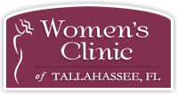
Open Door Women’s Clinic
Address: 1395 Cross Creek Cir, Tallahassee, FL 32301
Telephone: (850) 222-7077
Website: www.womensclinictallahassee.com
The Mission Open Door Women’s Clinic:
At Women’s Clinic they will administer a pregnancy test at no charge. If any woman has a positive test, the staff of Open Door will review all of their options and in some cases offer a free ultrasound. They offer current, medically accurate, unbiased information. Women’s Clinic serves clients throughout Florida’s Big Bend area and South Georgia. Open Door Women’s Clinic deals with pregnancy, abortion, parenting, pregnancy resources, or sexually transmitted diseases.

Testimonials:
-“The purpose of my project is to develop hands on tools to assist a client advocate in sharing message of sexual integrity in the counseling room.” – Melissa M.

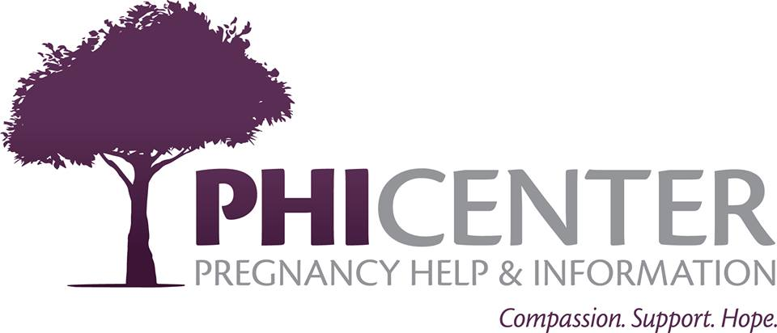
Pregnancy Help and Information (PHI) Center
Address: 1710 S Gadsden St, Tallahassee, FL 32301
Telephone: (850) 222-7177
Website: phicenter.org
The Mission of Pregnancy Help and Information Center:
The Pregnancy Help and Information Center offers services to women who believe they might be pregnant, those who are pregnant, and those with young children. They assist both mothers and fathers during pregnancy and after the birth of their child in obtaining the emotional and physical necessities for their family. All PHI Center services are free and confidential, regardless of your age, race, or religion.

Testimonials:
-“I cannot believe how much I have grown in just 8 weeks of my internship. I have learned so much about the way others live and how they raise their children.” –Natalie W.

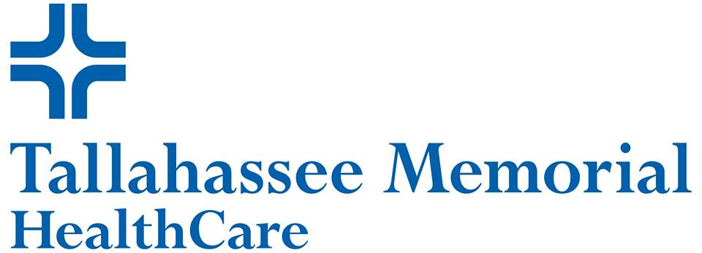
Tallahassee Memorial Hospital
Address: 1300 Miccosukee Rd, Tallahassee, FL 32308
Telephone: (850) 431-1155
Website: www.tmh.org
The Mission of Tallahassee Memorial Hospital:
With 772 beds, 3,500 employees and over 500 medical staff members, Tallahassee Memorial HealthCare is the seventh largest hospital in the state of Florida. TMH is a private, not-for-profit healthcare system with a vision of leading the communities we serve to become the healthiest in the nation. Providing innovative technology and a broad spectrum of services, Tallahassee Memorial HealthCare holds a number of important distinctions. TMH is home to the areas only state-designated Trauma Center and the Big Bend’s only accredited community hospital cancer program. TMH is recognized by the Society of Chest Pain Centers as an Accredited Chest Pain Center with PCI. Additionally, TMH has the only Neurologicaldiatric and Level III Neonatal Intensive Care Units.

Testimonials:
-“I have really enjoyed pushing myself to new limits and cannot wait for the next adventure that I will dive into.” – Mariah R.

-“Everyone was helpful. They knew what my specific job was as a COPE intern, and helped me to improve in that role. Top notch staff.” – Kahla V.

-“I wasn’t aware of how bad I was at communicating effectively with my supervisor until I was in this internship.” – Gabriela R.

Big Bend Homeless Coalition
Address: 2729 W Pensacola St, Tallahassee, FL 32304
Telephone: (850) 576-5566
Website: bigbendhc.org
The Mission of Big Bend Coalition:
The Big Bend Homeless Coalition is a nonprofit community-based organization that has served our community since 1986. They advocate for increased community, political and financial support for the homeless population and prevention of homelessness.

Testimonials:
-“I had two main responsibilities while at HOPE. They were teaching the Physical and Emotional Awareness for Children who are experiencing Homelessness (P.E.A.C.H) program and coordinating volunteer activities or inquires. Through each of these responsibilities I learned about teaching and coordinating people but also the issues surrounding and the various faces of homelessness.” –Alexandra
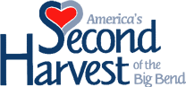
America’s Second Harvest Food Bank
Address: 110 Four Points Way, Tallahassee, FL 32305
Telephone: (850) 562-3033
Website: www.fightinghunger.org
The Mission of Second Harvest of Big Bend:
The mission is to feed the hungry in the Big Bend through their network of partner agencies, and to educate and engage the community in the fight against hunger. Established in 1982 as the Food Bank of Tallahassee, they began by picking up prepared and perishable foods at local restaurants and grocery stores (“food rescue”). Second Harvest continues that today through their Second Helpings Program, but has continued to expand our services as we work to feed the hungry.

Testimonials:
-“I have gained confidence of being a representative of the company, acquired greater responsibility due to being held accountable for my actions, I have become a team leader and now able to take on projects on my own.” – Susanne Botfeld

Bread and Roses Food Cooperative
Address: 915 Railroad Ave, Tallahassee, FL 32310
Telephone: (850) 425-8486
Website: www.facebook.com/breadandrosescoop
The Mission of Bread and Roses Food Coop:
As a member-owned and operated grocer, the Bread and Roses Food Cooperative provides an alternative to commercial, profit-oriented business. As members, they contribute our labor by working together, building trust through cooperation and teamwork. This enables us to keep prices as low as possible within the context of our values and principles. They seek to create a vibrant participatory democracy at every level, from policy making to store operations. Members share the benefits and responsibilities equally. They strive to be a responsible and ethical employer and neighbor, minimizing our carbon footprint by fulfilling our ecological responsibility.

Testimonials:
-“Due to the lack of communication between members and the clutter in the office I made creating a large message board and organizing the back office as my intern project.” – Shelby S.
-“Responsibilities were a good balance between small tasks and more involved tasks. For example the small tasks would entail organizing stock, working the cashier, organizing the office. More involved tasks were becoming head of a committee, learning how to make orders, communicating and working with other committees.” – Ryan B
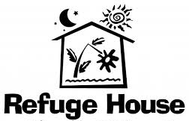
Refuge House
Address: Refuge House P.O. Box 20910. Tallahassee, FL 32316
Telephone: (850) 413-0395
Website: www.refugehouse.com
The Mission of Refuge House:
The mission of Refuge House is to provide direct services to victims of domestic violence and sexual assault, and to their children and families, as well as to eliminate such violence through community education and public advocacy.

Testimonials:
-“During my internship I helped return hotline calls to people who needed legal advice over the phone. I then qualified them by making sure they were below the poverty line. I also recorded the attorney’s advice on the legal service computer base.” – Hillary J.

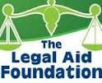
The Legal Aid Foundation of the Tallahassee Bar Association
Address: 301 S Monroe St, Tallahassee, FL 32301
Telephone: (850) 222-3292
Website: tallahasseebar.org
The Mission of Legal Aid Foundation of the Tallahassee Bar Association:
The members of the Tallahassee Bar Association have joined together to enhance the legal profession, promote fellowship among their colleagues and serve the community. They have taken an oath to uphold the law and practice it with professionalism and integrity. The Tallahassee Bar Association has been recognized by the American Bar Association and The Florida Supreme Court as a leading organization of volunteer spirit and service.

Testimonials:
-“ I highly recommend this site to anyone interested in going to law school or plan on working in a field that pertains to law or the criminal justice system.” –Marissa C.
-“I was responsible for completing the intakes onto the legal service, answering phone calls, calculating applications as well as inputting them, scheduling clients and attorneys as well as giving out TBA lawyer referrals and contacting attorneys about their cases and LRS reports.” – Marva A.

Genesis Church
Address: 4070 N Mission Rd, Tallahassee, FL 32303
Telephone: (850) 942-5433
Website: genesischurch.tv
The Mission of Genesis Church:
Know Christ. Make Him Known. Genesis Church has 4 main values love, service, generosity, and serving the community.

Testimonials:
-“ During the course of my internship I planned and coordinated the Tuesday activity time for our Ghazvini initiative along with implementing the Ghazvini monthly celebrations for the students who worked extra hard to succeed in their academics and behavior. I also had the privilege of co-managing Genesis Church’s children ministry and teenage ministry on a weekly basis.” – Justin H.

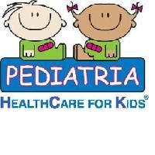
Pediatria: HealthCare for Kids
Address: 3492 Martin Hurst Rd, Tallahassee, FL 32312
Telephone: (850) 701-3920
Website: www.pediatriakids.com
The Mission of Pediatria:
Pediatria Healthcare provides innovative and superior health care services for medically complex children across a comprehensive continuum of care. Pediatria Healthcare's operating strategy establishes that services will be delivered primarily through a network of pediatric day healthcare centers and pediatric private duty nursing. These services are available to caregivers/family members and are generally referred through health care networks. Pediatria Healthcare is committed to providing its employees with excellent working conditions, fostering a high level of Espirit de Corps and genuine respect.

Testimonials:

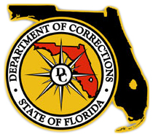
Florida Department of Corrections Headquarters
Address: 501 S Calhoun St, Tallahassee, FL 32399
Telephone: (850) 488-5021
Website: www.dc.state.fl.us/
The Mission of Florida Department of Corrections:
To promote safety of the public, our staff and offenders by providing security, supervision, and care, offering opportunities for successful re-entry into society, and capitalizing on partnerships to continue to improve the quality of life in Florida.

Testimonials:

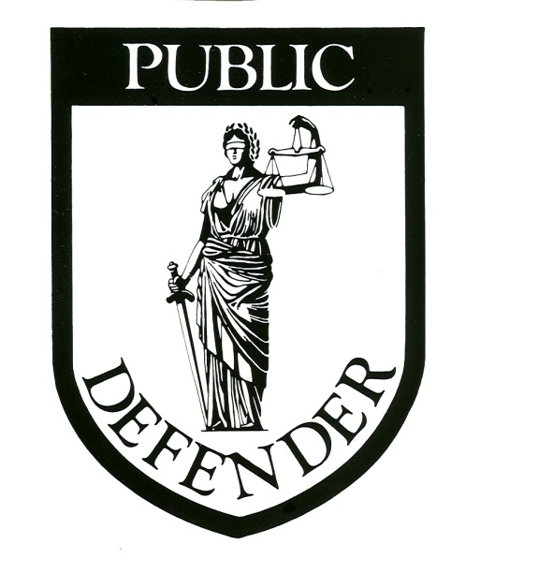
Florida’s 2nd Circuit Public Defender’s Office
Address: 301 S. Monroe Street, Suite 401, Tallahassee, FL 32301
Telephone: (850) 606-1000
Website: www.flpd2.com
The Mission of Florida’s 2nd Circuit Public Defender’s Office:
Providing top notch legal representation to clients in Franklin, Gadsden, Jefferson, Leon, Liberty, and Wakulla counties, and providing outstanding appellate representation to clients before the First District Court of Appeal & Florida Supreme Court.

Testimonials:

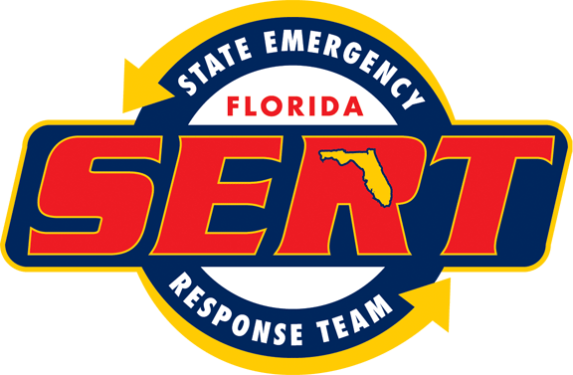
Florida Division of Emergency Management
Address: 2555 Shumard Oak Boulevard Tallahassee, Florida 32399
Telephone: (850)413-9969
Website: www.floridadisaster.org
The Mission of Florida Division of Emergency Management:
Working together to ensure that Florida is prepared to respond to emergencies, recover from them, and mitigate against their impacts.

Testimonials:

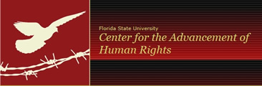
FSU Center for the Advancement of Human Rights
Address: 426 W Jefferson St, Tallahassee, Florida 32301
Telephone: (850)644-4550
Website: www.cahr.fsu.edu
The Mission of FSU Center for the Advancement of Human Rights:
Facilitating the development of interdisciplinary human rights courses throughout the university and of fostering human rights scholarship; establishing human rights field placements for FSU students and engaging in direct human rights advocacy; supporting non-governmental organizations (NGOs) throughout the world that engage in human rights work.

Testimonials:
-“The FSU Center for the Advancement of Human Rights commits itself to the legal aspects of human rights work. Many of the cases are of immigration, human trafficking, gender-based violence, domestic violence, or a combination of a few. I love learning about the legal side of human rights and, more than anything, I love being a part of it. I think one of my favorite parts so far has just been learning from Vania. Her desk is right by mine so I can ask her anything at any time, even if it’s not work- related. I have so many questions about human trafficking and just gender-based violence in general and I love having conversations with her where she can just answer all of them with such insight and she always offers something that I had never thought about before.” – Bianca J.

4-H
Address: 615 Paul Russell Road Tallahassee, FL 32301
Telephone: (850)606-5204
Website: http://www.4-h.org/
The Mission of 4-H:
4-H empowers youth to reach their full potential, working and learning in partnership with caring adults. As the youth development program of the Cooperative Extension System of land-grant universities, 4-H is the nation’s largest youth development organization, empowering six million young people throughout the United States. Cooperative Extension of 1862 and 1890 land-grant universities provide the leadership to engage young people in 4-H in all 3,007 counties of the United States. The impact of the Cooperative Extension partnership is profound, bringing together National Institute of Food and Agriculture of USDA, land grant universities and county government to resource learning opportunities for youth.

Testimonials:

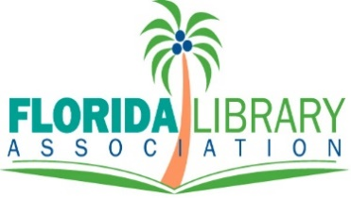
Florida Library Association (FLA) Special Events Internship

Description
The Florida Library Association is a 501(c)(3) nonprofit that provides statewide advocacy, professional development and networking opportunities for libraries and librarians throughout the state. We are looking for the perfect candidate interested in Meeting/Event Planning and Nonprofit Management to participate in an internship with our organization. This is a great opportunity for someone looking for a career in event planning, fundraising and nonprofit management. As an intern, you will be involved in the coordination of events and be a part of the event planning process first-hand.

Responsibilities
- Assist Event Planners with special projects and administrative duties relating to the 2018 FLA Annual Conference – including conference registration, meeting planning, and networking events
- Assist with social media, PR and communications - including creating advertisements, way-finding signs, and e-mail blasts
- Assist with email correspondence and organization

Qualifications
-You must be a Junior or Senior in college to apply.
-A passion for the meeting/event/nonprofit planning industry
-Previous meeting/event planning experience preferred.
-Great attitude
-Good work ethic
-Outgoing, articulate and personable
-Good communication and interpersonal skills
-Familiar and professional on social media
-Can work in a fast-paced environment and keep a level head
-Multi-tasker
-Proficient in Microsoft Office programs
-Able to work well as part of a team
-Graphic/website design experience is a plus. Please confirm if you have graphics experience when you apply.

Start Date: Monday, January 8th, 2018

Hours: 12-16, flexible, based on your schedule. Monday-Friday 9am-5pm

Location: The Florida Library Association, 541 E. Tennessee St. Suite 103, Tallahassee, FL 32308

Compensation: You will receive internship credit upon satisfactory completion

If you are interested in this internship please send a resume and cover letter by January 8th, 2018 via email to:
karen@flalib.org.

